REPORT ON ONLINE JOB PORTAL

Week 1 – Task

NAME: SOUNDHARYA.S

REPORT: Workflow of Online job Portal Website

DATE: 31-07-2020

Report on Online Job Portal

Website: <https://www.freshersworld.com/>

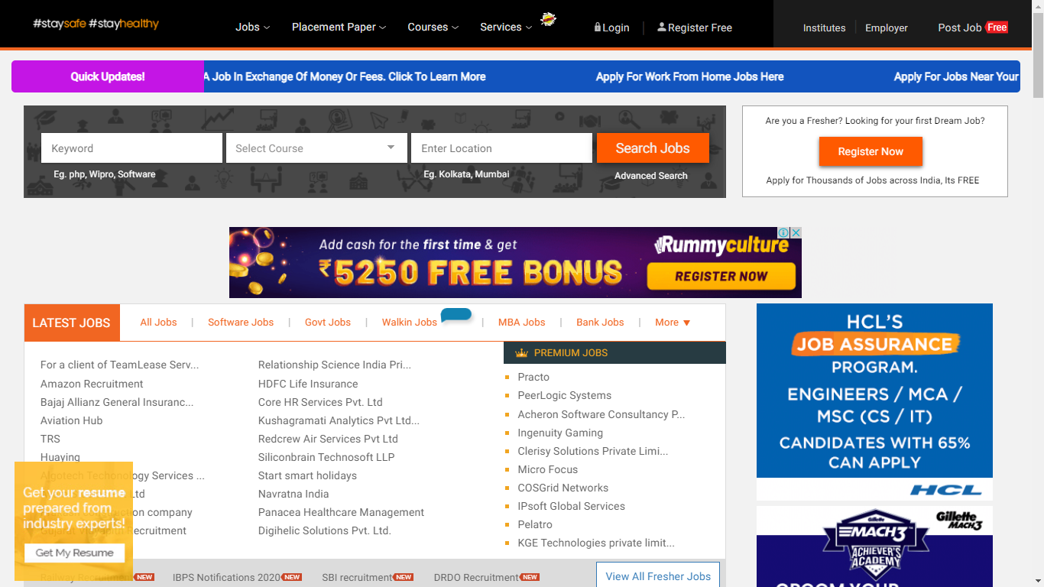

This is the UI of the Website.

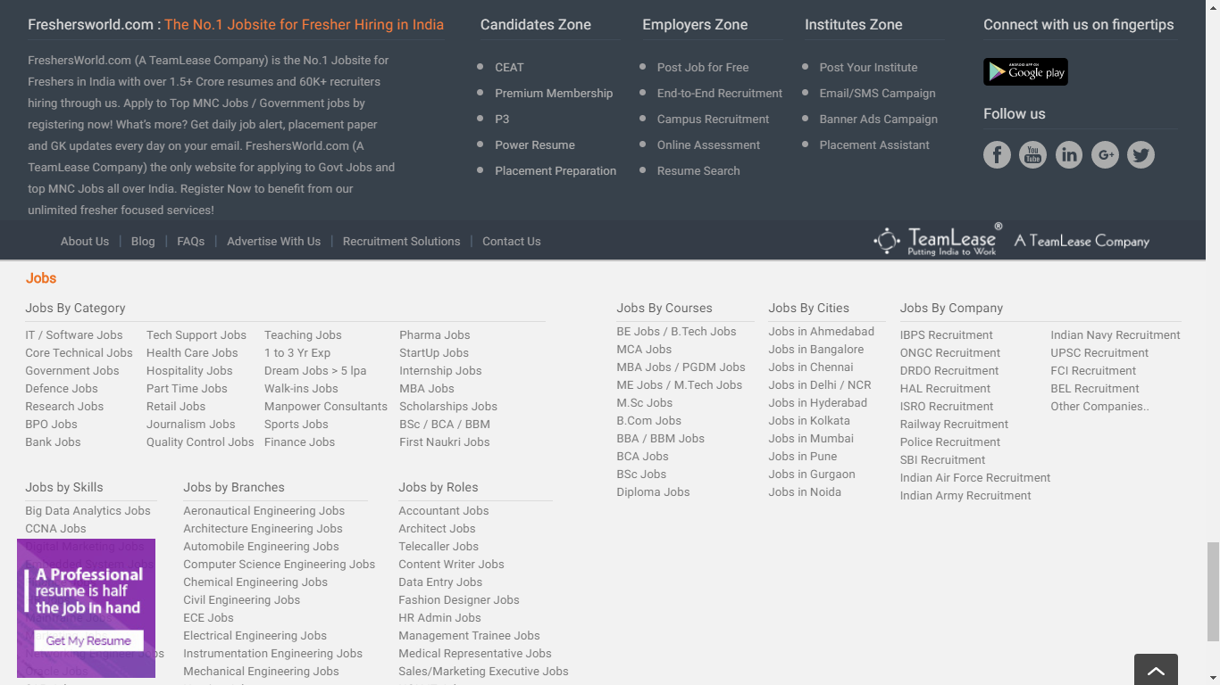

This is the footer of the Website.

WORKFlOW:

* This Website contains 9 nav-bars. If you are new to [www.freshersworld.com](http://www.freshersworld.com) first of all you have to click the Register Free icon in the top of the website.



* The Job seeker as well as the job provider can give their details and do register in the given form below:

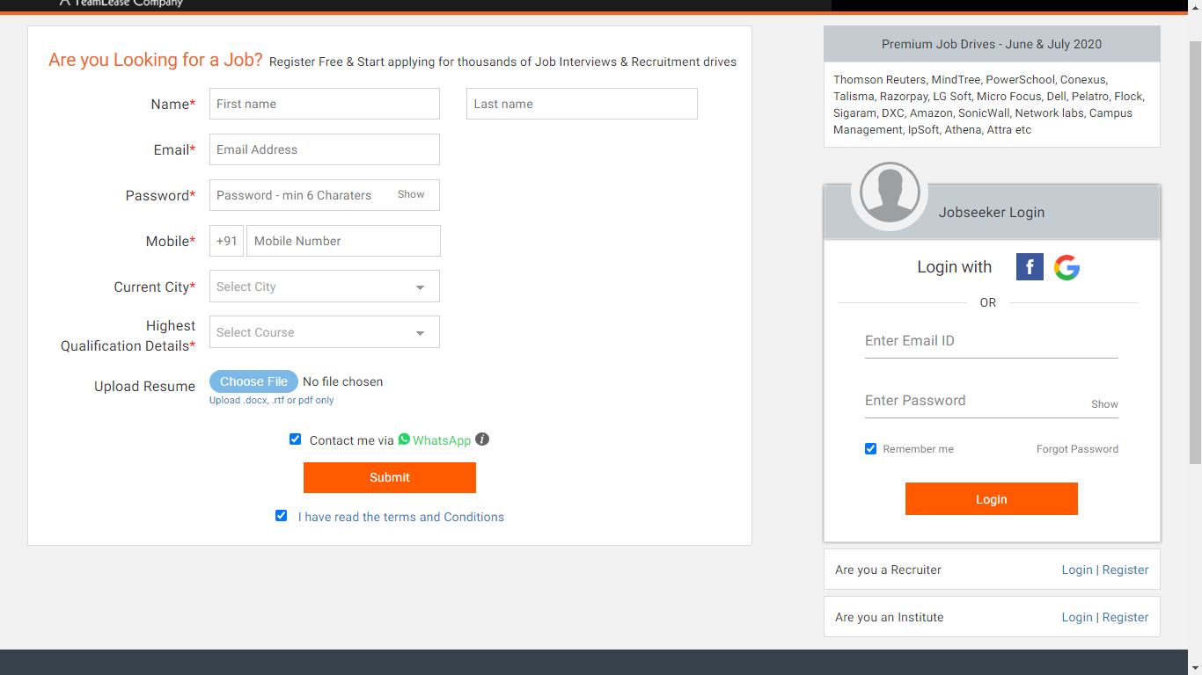

* After registering one can Login with their required Email ID and Password.
* One of the feature is recent updates regarding job or anything else from this website is updated in the running feed on the top of the website.

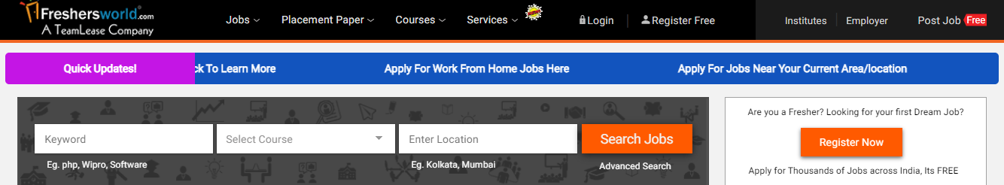

* In this website, the jobs are organized in a specific sector and industry that we are looking for.
* The Job Seeker can select the type of work and Select the Field of study and the location in the given dropdown box. So that it is easy to filter the jobs that we are specifically looking for.

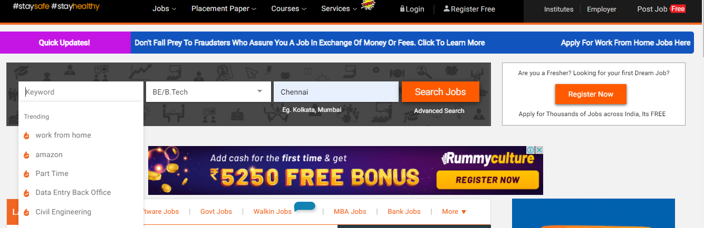

* For example if a Job Seeker giving job as Part Time job , Course as B.E/B.TECH and the correct Location, after clicking on the Search Jobs , various jobs that he is looking for will be displayed.

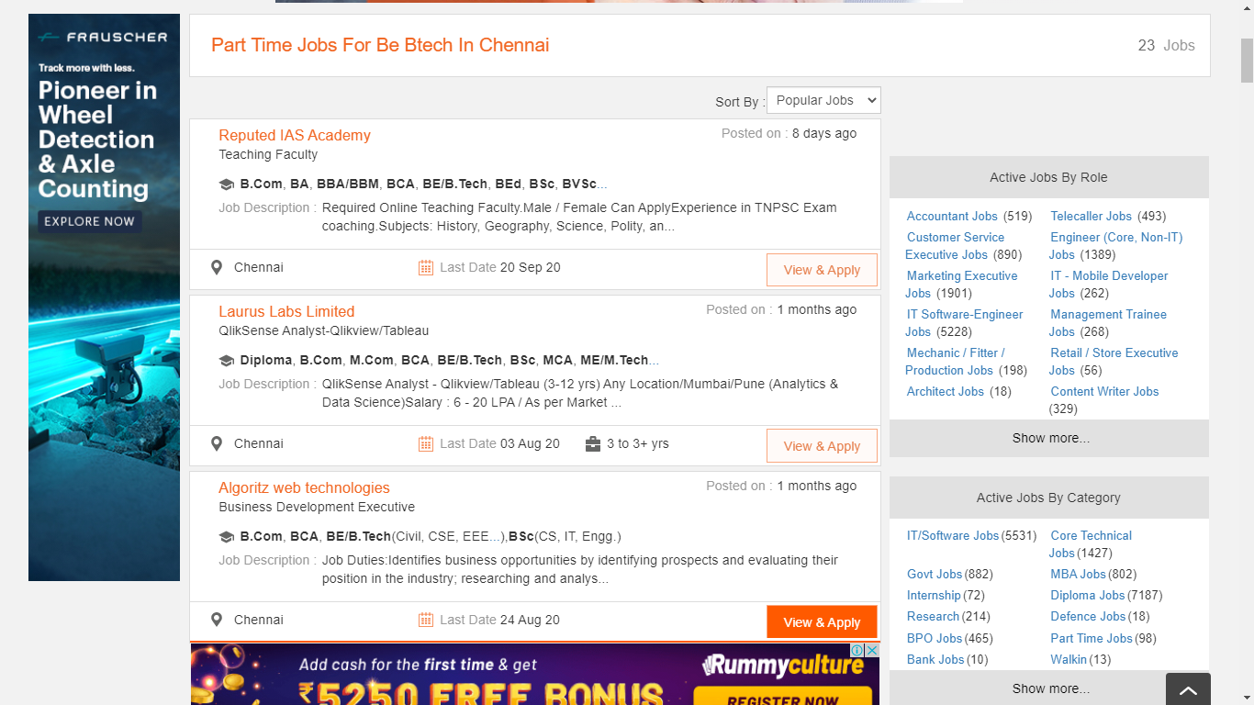

* So one can click on View & Apply option to view about the company details and apply to the job !



* After doing this the details regarding the company that Job Seeker has selected will be displayed.

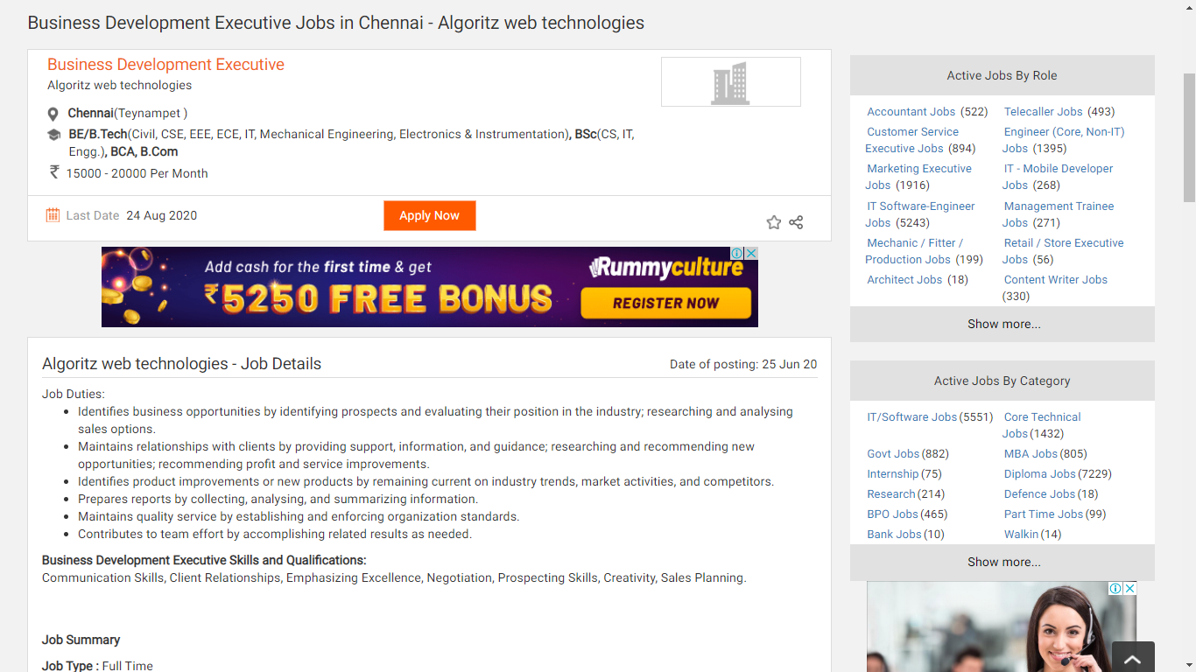

* Further if Job Seeker want to apply click on the Apply Now button.
* After clicking on Apply Now button a form will be displayed saying that you have to enter the details to the company with the fields required.

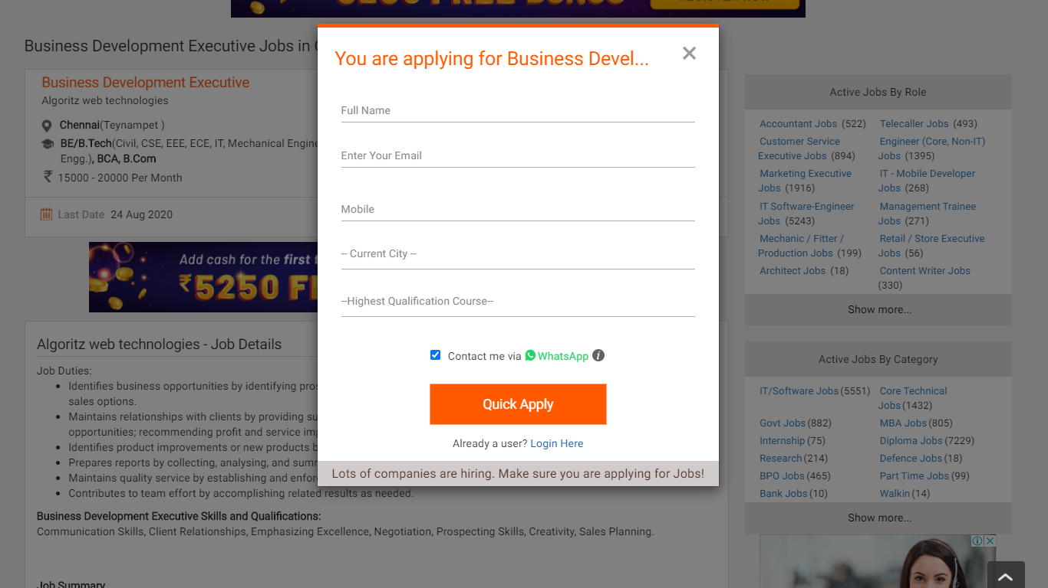

* After doing all these steps finally click on Quick Apply.
* So this website provides very simplest way to apply for jobs.

Some of the popular Online Job Portal websites are:

* [www.naukri.com](http://www.naukri.com)
* <https://www.monsterindia.com/>
* <https://www.shine.com/>
* <https://www.linkedin.com/>
* <https://www.freelancemyway.com/>
* <https://www.indeed.co.in/>

Thank You!